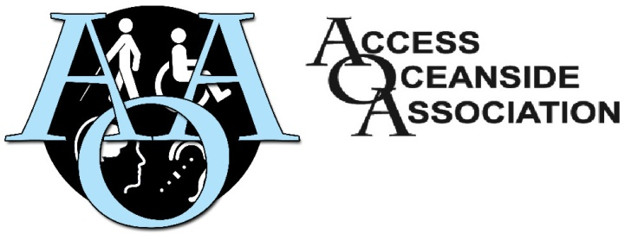

**Wednesday, January 8, 2025**

**12:00 noon to 2:00 pm**

(Please bring your own Minutes/Agenda)

**Quality Foods Parksville : Community Meeting Room “Upstairs”**

371 Alberni Highway at Despard

**AGENDA**

1. Call to Order/Introductions
2. Approval of Minutes and Agenda
3. Liaison Reports
   1. Parksville Council Amit G.
   2. Qualicum Beach Council Scott H.
4. Items Arising/Action List Items
   1. AOA Standing Banner Ralph T.
   2. Certificates of Appreciation Ralph T.
   3. Commercial Accessibility Project Maggie T.
5. New Business
6. Financial Report Ralph T.
7. Correspondence
8. Round Table Discussion and Wrap up

**Next Regular Meeting : February 12, 2025 12:00 to 2:00 pm**

Quality Foods Parksville 371 Alberni Hwy at Despard

Community Meeting Room “Upstairs”